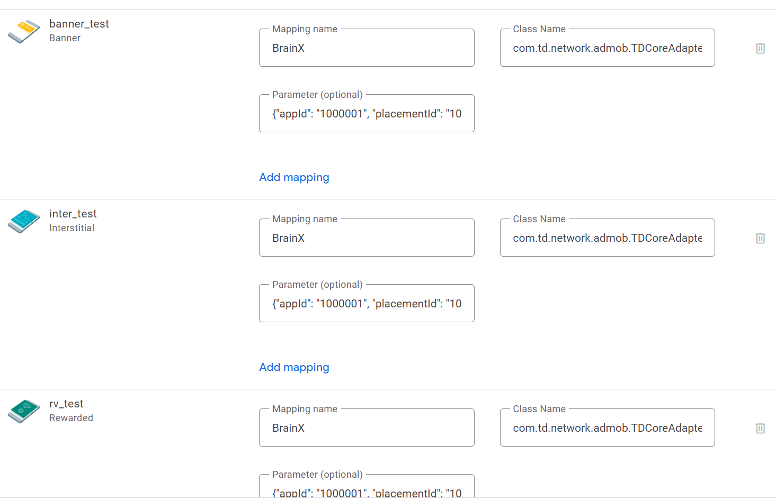

Adapter Path: com.td.network.admob.TDCoreAdapter

Parameter: {"appId": "YOUR_APP_ID", "placementId": "YOUR_PLACEMENT_ID"}

Notice：SDK Proguard rules：  
     -keep class com.td.** { *; }  
    -keepclassmembers class com.td.** {  
        @com.td.* public *;  
    }